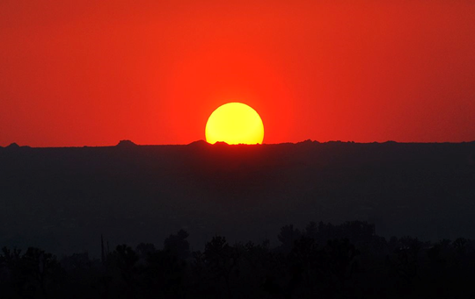

TOWN OF HALLIE
ANNUAL MEETING OF THE ELECTORS
TUESDAY, JUNE 10, 2020 at 7:00 PM
HALLIE SANITARY DISTRICT BUILDING
13034 30th CHIPPEWA FALLS, WI. 54729

1) Meeting call to order per ss 60.11

2) Annual Reports:
A) Clerk/Treasurer
B) Fire/EMS
C) Roads

3) Business of the Electors

4) Annual Meeting date will be April 20, 2021 at 7:00pm

5) Motion to Adjourn

John R. Andersen
Clerk/Treasurer

