Town of Halle 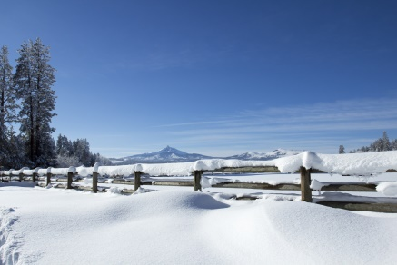
Regular Meeting
February 9, 2022
13034 30th Ave.
5:00 PM

1) Call Meeting to order per ss 19.84

2) Roll Call: Mr. Marquardt _____ Mr. Bergeman _______ Mr. Eslinger ______

3) Members of the public wishing to be heard

4) Approve minutes of the November 10, 2021 Meeting

5) Old Business:
A) 10th Ave. LRIP application
B) Farm Buildings on County Trunk P
C) Comprehensive Plan and Survey Questions status

6) New Business:
A) 2021 Budget closeout
B) 2022 Election Status
C) Towns Association District Meeting March 5, 2022 Eau Claire
D) ARPA Fund allocation, status and discussion

7) Correspondence:

8) Department Reports
A) Roads
B) Fire Department
C) Clerk /Treasures Report

9) Approve Vouchers and Pay Bills

10) Set next meeting date

11) Adjourn

