Town of Halle 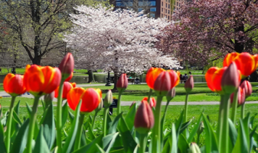
Regular Meeting
April 19, 2022
13034 30th Ave.
5:00 PM

1) Call Meeting to order per ss 19.84

2) Roll Call: Mr. Marquardt _____ Mr. Bergeman _______ Mr. Eslinger ______

3) Members of the public wishing to be heard

4) Approve minutes of the February 9, 2022 Meeting

5) Old Business:
A) County Highway P property
B) 10th Ave LRIP Application
C) ARPA Fund Status
D) Comprehensive Plan Results
E) Update on Bloomer Tele Com Application
F) Election Update

6) New Business:
A) Grant for Hallie Fire Station
B) Appoint/Approve Fire District Board Member
C) Appoint/Approve Town of Hallie Fire Commission Member 5 year term

7) Correspondence:

8) Department Reports
A) Roads
B) Fire Department
C) Clerk /Treasures Report

9) Approve Vouchers and Pay Bills

10) Set next for May 19th 2022 at 5:00 PM

11) Adjourn

